CENWP-OD-B 18 June 2023

MEMORANDUM FOR THE RECORD

SUBJECT: 23BON031 MFR CI Pond Pacific Lamprey Morts

On 18 June, Bonneville Fisheries discovered two Pacific Lamprey mortalities in the pond near FV5-4 of the Cascade Island Lamprey Passage System. The fish were scanned for PIT tags, inspected, and returned to the river.

- Species – Pacific Lamprey (Entosphenus tridentatus)
- Origin – Unknown
- Length – Bottom 60.3 cm. Top 33 cm.
- Marks and tags – None
- Marks and Injuries found on carcass – None
- Cause and Time of Death – Unknown
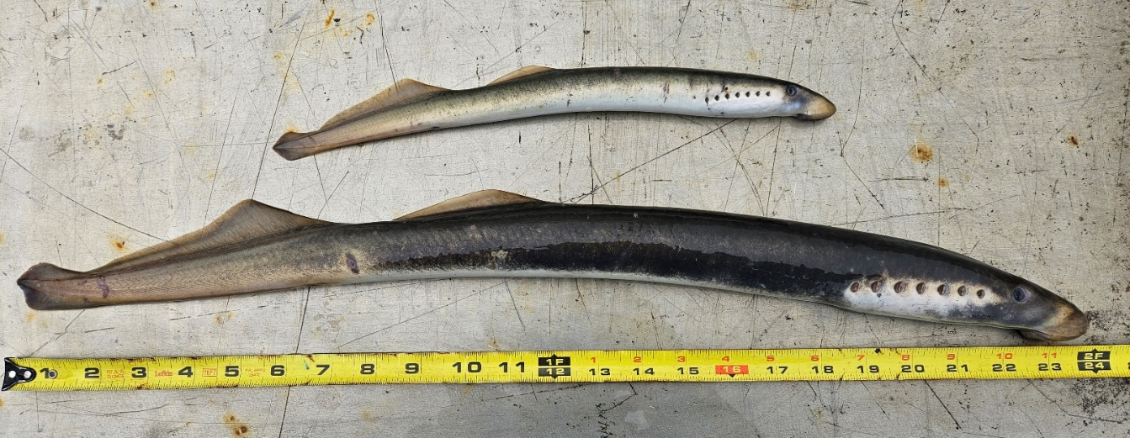
- Future and Preventative Measures – None

Sincerely,
Bonneville Project Fisheries
Comments from others –
-----Original Message-----
From: Ralph Lampman <lamr@yakamafish-nsn.gov>
Sent: Wednesday, June 21, 2023 12:48 PM
To: Mackey, Tammy M CIV USARMY CENWP (USA) <Tammy.M.Mackey@usace.army.mil>
Subject: [URL Verdict: Neutral][Non-DoD Source] Re: FPOM: Official Coordination - MFRs regarding Pacific lamprey morts
For this smaller one (dwarf) in 4th attachment, it's possible that the smaller one is a W. River Lamprey, so good to check the dentition.
https://www.pacificlamprey.org/wp-content/uploads/2022/03/2017-Lamprey-Identification-Guide-Final.pdf <Blockedhttps://www.pacificlamprey.org/wp-content/uploads/2022/03/2017-Lamprey-Identification-Guide-Final.pdf> (33 cm is considered the general max size for W. River Lamprey)

We are trying to understand more about the ecology of both W. River Lamprey as well as dwarf Pacific Lamprey.
~Warm Regards~
Ralph Lampman
COLUMBIA RIVER| Honor. Protect. Restore
Yakama Nation FRMP, Pacific Lamprey Project
lamr@yakamafish-nsn.gov <mailto:lamr@yakamafish-nsn.gov>
509-388-3871

